Southern New Hampshire University
Trangdai Huynh
CS-330: Comp Graphic and Visualization
2-3 Milestone One: Project Proposal
Fernando Nieto
January 17, 2026

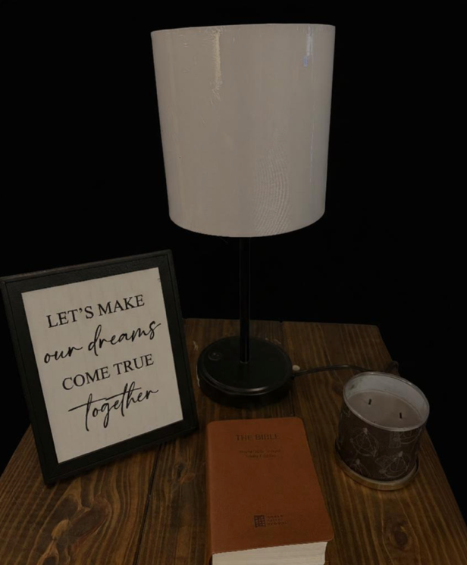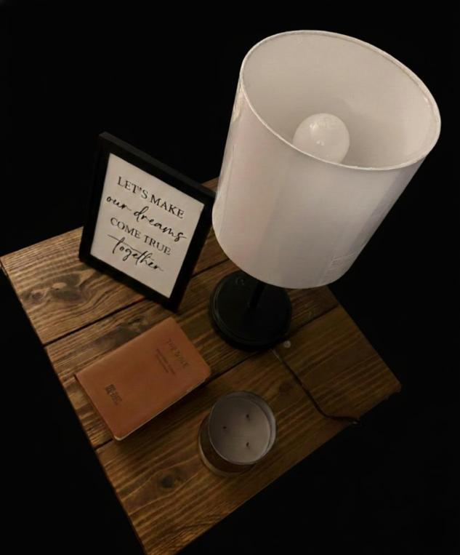
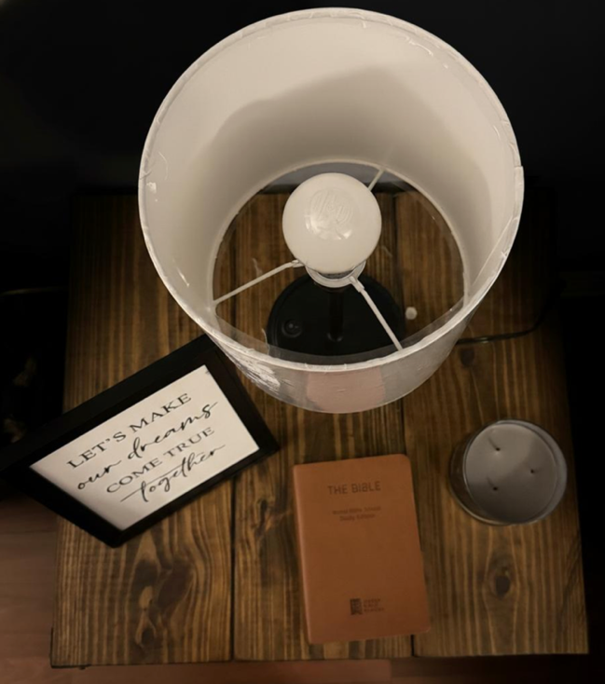

I. Selection of Scene and Objects: For this replication, I have selected a still-life composition featuring a Table Lamp, a Leather-bound Bible, a Three-wick Candle, and a Framed Quote. These objects are placed on a dark wooden surface. To ensure a high-fidelity 3D reconstruction, I have captured the scene from three distinct angles: a bird’s-eye view, a direct front view, and a 45-degree perspective view.
Rationale: This scene is ideal because it provides a clear contrast between organic and geometric forms. The lighting is high-contrast, emanating from a single source within the scene, which offers an exciting challenge for 3D light placement and shadow rendering.
II. Geometric Breakdown I will use five basic 3D shapes to reconstruct this scene, ensuring that the proportions and silhouettes match my reference photos.
- The Table Lamp (Composite Object): This is the most complex item in the scene, constructed from four distinct shapes. I will use a Cylinder for the base, a thinner Cylinder for the stem, a Sphere for the bulb, and a Tapered Cylinder for the shade. Using a tapered cylinder allows me to accurately replicate the slight inward slope of the fabric shade seen in my photos.
- The Candle: This will be modeled using a Cylinder. To add a level of sophistication, I will use a "nested" approach, where an inner cylinder represents the wax and the outer represents the glass.
- The Bible and Framed Quote: Both will be created using Box primitives. I will scale them to different thicknesses. The Bible requiring more depth to represent its pages, and the Frame requiring a thinner profile.
- The Surface (Grounding Plane): I will use a Plane to serve as the table. This is a critical component as it grounds the rest of the objects, allowing them to cast realistic shadows and providing a sense of scale and placement in the 3D world.
III. Scope and Realism: My approach is designed to be achievable while maintaining a high level of technical detail. By breaking down the complex form of the lamp into simple primitives, I am demonstrating how 3D environments are built from the ground up. The inclusion of the Tapered Cylinder and the specific placement of the Bible and Frame at different angles will ensure the final 3D scene feels dynamic and intentional.

